

**Agri-Shop Online Application**

**Software Requirement Specification (SRS) Document**

**Sprint 1 Implementation**

**Project Timeline: 20.10.2022 to 27.10.2022**

**INDEX**

1. Introduction

1.1 Purpose ------------------------------- 4

1.2 Intended audience ------------------------------- 4

1.3 Intended use ------------------------------- 4

1.4 Scope ------------------------------- 4

2. Overall description ------------------------------- 5

2.1 Assumptions and dependency ------------------------------- 5

3. System feature and requirements ------------------------------- 5

3.1 Functionality ------------------------------- 5

3.1.1 ASOA_01->Registration process ------------------------------- 5

3.1.2 ASOA_02-> Choose Category ------------------------------ 5

3.1.3 ASOA_03-> Product registration ------------------------------ 6

3.1.4 ASOA_04-> Product Quantity and Price ------------------------------ 6

3.1.5 ASOA_05->Update Farmer details ------------------------------ 6

3.1.6 ASOA_06->Customer transaction ------------------------------ 6

3.1.7 ASOA_07-> Select Category ----------------------------- 6

3.1.8 ASOA_08-> validate order ----------------------------- 6

3.1.9 ASOA_09-> Bill generation ------------------------------ 6

3.1.10 ASOA_10-> Farmer auto update ----------------------------- 6

3.1.11 ASOA_11-> Admin update farmer ----------------------------- 6

3.1.12 ASOA_12-> Sales report generation ------------------------------ 6

3.1.13 ASOA_13-> Consolidated transactions ------------------------------ 7

3.2 System requirement ------------------------------ 7

3.2.1 Tools to be used ------------------------------ 7

3.3 System feature ------------------------------ 7

4. Data Flow Diagram

4.1 DFD level 0 ------------------------------- 8

4.2 DFD level 1 ------------------------------- 9

### 

### **Introduction: -**

The introduction of the software requirement specification provides an overview of the entire software. The entire SRS with overview description purpose, scope, tools used and basic description.

The aim of this document is to gather, analyze and give an in-depth insight into the complete Agri-Shop Online buying and selling application by defining the problem statement in detail.

The detailed requirements of the Agri-Shop Online buying and selling application is provided in this document.

**1.1** **Purpose**: **-**The purpose of this document is to show the requirements for the Agri-Shop Online buying and selling Application, which creates a direct contact between the farmers and the retailers or customers without the involvement of the mediators.

**1.2** **Intended Audience: -**This document is intended to be read by, Client.

**1.3** **Intended Use: -**

* Development Team
* Maintenance Team
* Clients

Since this a general-Purpose Software any one can access it.

**1.4** **Scope: -**

This project aims to create the development of an Agri-Shop Online buying and selling application. This system consists of an application which will serve as a platform for farmer to sell their products and retailers or customers to buy their farm products.

This system aims at giving a profitable price to farmers for their farm products cutting the middlemen. This allows the retailers or the customers to buy products from the farmers at a lower than the normal price.

**2. Overall Description: -**

Agri-Shop Online buying and selling Application, a e-commerce platform in which the farmers sell the their product directly to the customers or to the retailers. This system consists of the database which holds the details of the farmers and the details of the products like quantity, price, they are selling.

The details of the farmers can be changed even after the registration and the access to edit those information is given to the admin and the farmers. And also some limitations were given to both customers and the farmers so that we ensure all the farmers gets the benefits of this application.

The main purpose of this application is to provide the farmers with a profitable price for their products by cutting the middleman / Mediator and provides the customer with the products with lower price than the normal price.

**2.1 Assumptions and Dependency: -**

* System should have any flavor of Linux installed.
* System should have either 4GB or more RAM.
* The service is used preferably on a desktop or laptop.

**3.System Features and Requirements: -**

**3.1 Functionality: -**

**3.1.1 ASOA_01->Registration process:** Farmer who are willing to sell their products need to register using their personal details which includes the aadhar number for validations.

**3.1.2 ASOA_02-> Choose Category**: Farmers will be prompted during registration as to which category they choose among the below given categories with the limitation that he should choose only one category

a) Fruits

b) Vegetables.

c) Food Grains.

**3.1.3 ASOA_03-> Product registration**: Under the selected category a farmer will be allowed to register maximum 4 products. This is done to give a fair chance to all the other farmers.

**3.1.4 ASOA_04-> Product Quantity and Price:**  After the successful registration the farmers need to specify the product quantity and the price of the products..

**3.1.5 ASOA_05->Update Farmer details :** The farmers are given access to update their personal details and the quantity and the price of the items they sell even after the registration process.

**3.1.6 ASOA_06->Customer transaction:** This functions gets the name and the aadhar number from the customer and check against the database and begins the transaction for the customers.

**3.1.7 ASOA_07-> Select Category:** After starting the transaction the customers were asked to select a category . Upon selecting the category the customers were able to see all the products details available under that category.

**3.1.8 ASOA_08-> validate order:**  The customers are allowed to buy a maximum of 3 products only. This function validates the number of products ordered by the customer.

**3.1.9 ASOA_09-> Bill generation:**  On selecting the products and their quantity the customers are taken to the bill created for their order. The customers need to confirm the order by making their payment.

**3.1.10 ASOA_10-> Farmer auto update:** The farmer details are updated automatically to the database after each purchase made by any customers.

**3.1.11 ASOA_11-> Maintain farmer details:**  This function provides access for the admins to edit, delete or view the details of the farmers in the database.

**3.1.12 ASOA_12-> Sales report:**  Admin can generate a report on the sale of a particular farmer. This function helps the admin to give the sales report on a particular farmer.

**3.1.13 ASOA_13-> Consolidated transaction report:** The consolidated transactions of the purchases done by the customer can be generated by the admin using this function.

**3.2 System Requirements: -**

### **3.2.1. Tools to be used:**

* Valgrind
* Splint
* Makefile
* C File Handling

### **3.3 System Features: -**

### Supportability:The system is easy to use.

* Design Constraints: The system is built using only C language.
* Usability:The Agri-shop online buying and selling application can be used to cut down the mediators in between the farmers and the customers.

Making easy selling and buying experience for both farmers and the customer by providing a e-commerce platform, which gives the farmers the whole profit of their yield and for the customers the healthy and a product which is lower in price than the normal one.

* Reliability & Availability**:** The system is available 24/7 that is whenever the user would like to use the system, they can use it up to its functionalities.

### Performance: The system will work on the user’s terminal**.**

**4. Data Flow Diagram:**

**4.1 DFD Level 0 -**

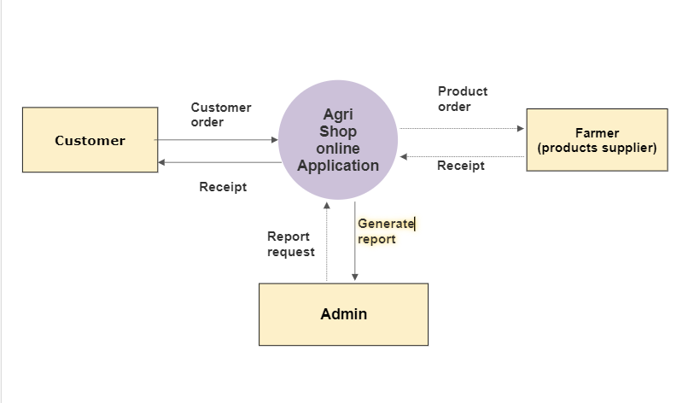

**4.1 DFD Level 1 -**

